GenSTEAMers | Chatting with AI | Modular Pathway
CORE 3 Completed Revision-Decision Examples
School Recycling Helper | Completed Scratch student-style models

How to use this example
This file shows both valid CORE 3 paths. Example A uses peer evidence to improve one feature. Example B shows how a group can keep a feature as designed when the evidence supports that decision. These are models, not mandatory topics.

Prototype handover
Handover item | Example content
Chatbot name | School Recycling Helper
Target user | A younger student sorting common school waste
Purpose | Help users choose the correct route for paper, plastic and batteries
Suggested tests | 1; 2; 3
CORE 1 principle | A good chatbot should explain its limits.
Implemented feature | Final else branch with fallback and limitation messages
Exact principle test | Can I recycle medicines?
Expected evidence | The chatbot states its limited categories and redirects the user to a teacher.
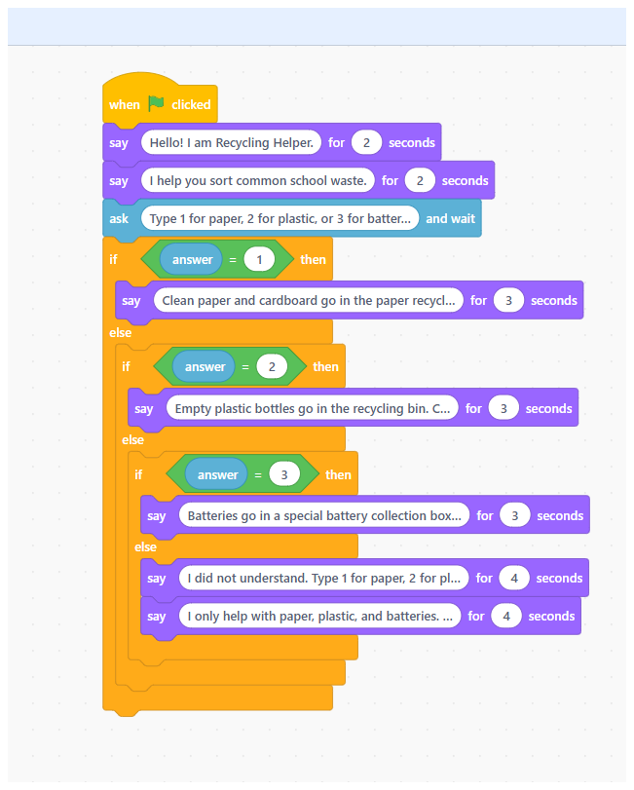
Figure 1. CORE 2 prototype before independent peer testing.

Example A - Completed peer-test record
Mission | Input | Observed behaviour | Judgement + evidence
CORE 1 principle | Can I recycle medicines? | The chatbot said it only helps with paper, plastic and batteries and told the user to ask a teacher. | Confirmed - it stated its scope and redirected the user.
Fresh User Challenge | 4 | The chatbot first listed 1, 2 and 3 and then showed a separate limitation message telling the user to ask a teacher. | Partly - the guidance was correct, but it was split across two consecutive messages.
Optional expected use | 1 | “Clean paper goes in the paper recycling bin.” | Yes - the response matched the menu category and was clear.

Example A - Peer evidence and revision decision
Verified strength
The limitation response worked during the exact CORE 1 principle test. The chatbot did not guess about medicines and redirected the user to a teacher.
Key finding
The Fresh User Challenge 4 produced correct recovery and scope guidance, but the information was divided between two consecutive messages.

Example A - Compare with the CORE 2 mini-test and decide
CORE 2 baseline | CORE 3 peer evidence | Comparison
Unsupported input produced the planned fallback and limitation messages. Group judgement: Yes. | Input 4 produced correct guidance, but the new user received it in two separate messages. | Same result, but peer testing revealed a clarity and timing issue. Decision: Improve the final else branch by combining the two messages.

Example A - Improve one feature
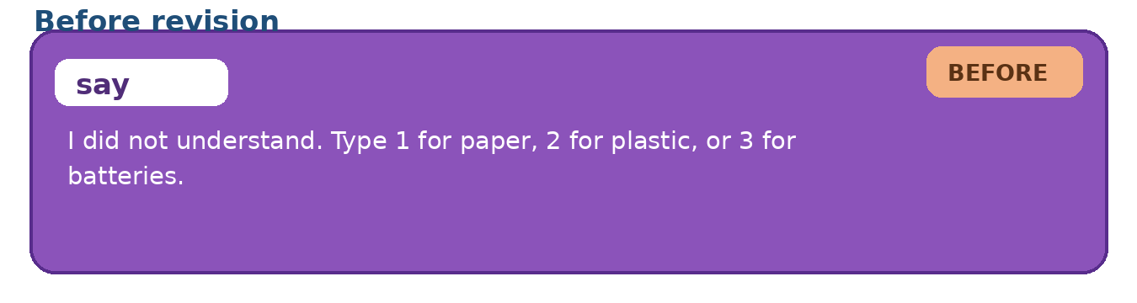
Before: recovery and limitation guidance in two consecutive messages.
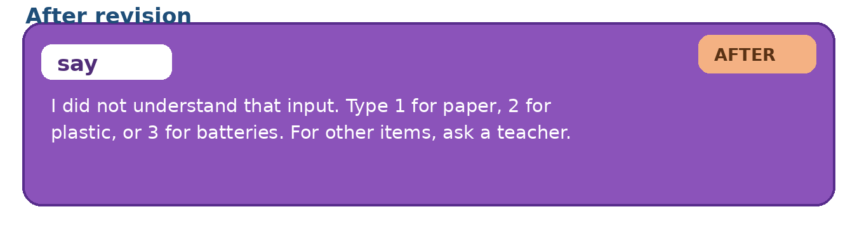
After: one combined recovery, scope, and human-redirection message.
Before | After | Reason
Message 1: “I did not understand. Type 1 for paper, 2 for plastic, or 3 for batteries.”  Message 2: “I only help with paper, plastic, and batteries. For other or dangerous items, ask a teacher.” | I did not understand that input. Type 1 for paper, 2 for plastic, or 3 for batteries. For other items, ask a teacher. | The change keeps the same scope and categories while presenting the guidance more clearly in one response.

Example A - Same-input re-test
Re-test input | Revised behaviour | Judgement
4 | The chatbot gave one combined message with valid choices and added: “For other items, ask a teacher.” | Fixed - the user can now recover and understands what to do outside the chatbot scope.

Example A - Final compact record
Final reflection item | Student-style response
What our chatbot now does well | It gives three clear recycling responses and explains its limits when the question is outside its topic.
Revision decision | Improve. The recovery and limitation guidance should be combined into one clearer response.
Evidence used | Peer testers entered 4 and received correct guidance, but it was split across two consecutive messages.
Verification result | Fixed. The same input now gives one combined recovery and human-redirection message.
Final CORE 1 principle validation | Confirmed. The original principle test and the revised fallback both show clear limits.
Remaining limitation | The chatbot only understands the menu choices 1, 2 and 3; it cannot recognise natural-language categories.
Why a human is still needed | The chatbot covers only three items, so a person must check other or potentially unsafe waste questions.

Why Example A is strong
· The peer test was independent and based on observed behaviour.
· The priority issue came from a specific input and led to one focused change.
· The same input was re-tested, and the final record states both a strength and an honest limitation.

Example B - Keep as designed
A different group tests a Library Opening Hours chatbot. The CORE 1 principle is: “A good chatbot should be clear about its scope.”
Test | Input | Observed behaviour | Judgement
CORE 1 principle | Can you renew my book for me? | The chatbot says it only gives opening-hour information and asks the user to contact the library desk. | Confirmed - scope and human redirection are clear.
Fresh User Challenge | What time are you open on Saturday? | The chatbot gives the Saturday opening time clearly. | Yes - a new wording still leads to a useful response.
Confirmation test | What time do you close on Monday? | The chatbot gives the Monday closing time and stays within its scope. | Confirmed.
Revision decision: Keep as designed. Both mandatory tests showed clear scope and useful behaviour. The group did not make a cosmetic change. The confirmation test supported the decision.
Remaining limitation: the chatbot cannot renew books or answer questions about individual accounts; a human or library system is still needed.

